

***School of Mechanical & Manufacturing Engineering (SMME),***

***National University of Science and Technology (NUST),***

***Sector H-12, Islamabad***

Program: BE-Aerospace Section: AE-01

Session: Fall 2023 Semester: 1st

Course Title: Fundamentals of Programming (CS-109)

***“Assignment No.1”***

***Name:* Abdul Manan Rao**

***CMS:*** **465672**

**Question no. 1:**

**Write a C++ program, take two strings as input from user and check if both strings are equal or not. If they are equal, make them unequal by rotating string. e.g., Hello is turned into olleH etc.**

#include <iostream>

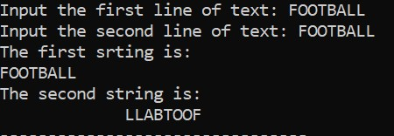#include <limits>

using namespace std;

int main(){

char a[25], b[25];

cout<<"Input the first line of text: ";

cin.get(a, 25);

cin.ignore(numeric_limits<streamsize>::max(), '\n');

cout<<"Input the second line of text: ";

cin.get(b, 25);

cout<<"The first srting is: \n"<<a<<endl;

cout<<"The second string is: \n";

for (int i=24; i>=0; i--){

if (a[i]==b[i]){

cout<<b[i];

}

}

return 0; CODE:<01.cpp>

}

**Question no. 2:**

**Write a C++program for a string which may contain lowercase and uppercase characters. The task is to remove all duplicate characters from the string and find the resultant string.**

#include <iostream>

#include <string>

using namespace std;

int main(){

string a;

int l;

cout<<"Input the string text: ";

getline(cin, a);

l= a.length();

for (int i=0; i<=l; i++){

for (int j=0; j<=l; j++){

if (tolower(a[i])==tolower(a[j]) && i!=j){

a.erase(j, 1);

j--;

l=a.length();

}

}

}

cout<<a;

return 0;

} CODE:<02.cpp>

**Question no. 3**:

**Suppose an integer array a[5] = {1,2,3,4,5}. Add more elements to it and display them in C++.**

#include <iostream>

#include <string>

using namespace std;

int main(){

string a;

int l;

cout<<"Input the string text: ";

getline(cin, a); CODE:<03.cpp>

l= a.length();

for (int i=0; i<=l; i++){

for (int j=0; j<=l; j++){

if (tolower(a[i])==tolower(a[j]) && i!=j){

a.erase(j, 1);

j--;

l=a.length();

}

}

}

cout<<a;

return 0;

}

**Question no. 4:**

**Write a C++ program that uses a while loop to find the largest prime number less than a given positive integer N. Your program should take the value of N as input from the user and then find the largest prime number less than or equal to N. You are not allowed to use any library or pre-existing functions to check for prime numbers.**

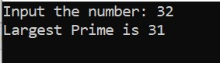

#include <iostream>

using namespace std;

int main(){

int num, i;

bool value;

cout<<"Input the number: ";

cin>>num;

while (num>=2){

i=2;

value=false;

while(i<num){

if(num%i==0){

value=true;

break;

}

i++;

}

if(value==false){

cout<<"Largest Prime is "<<num<<endl;

break;

}

num--;

} CODE:<04.cpp>

return 0;

}

**Question no. 5:**

**Implement Bubble Sort on an array of 6 integers.**

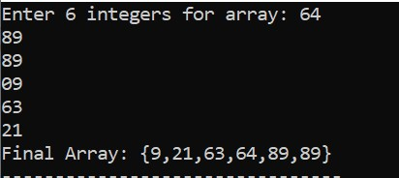# include <iostream>

using namespace std;

int main (){

int temp, len = 6, arr[len];

cout<<"Enter "<<len<<" integers for array: ";

for (int i = 0; i<len; i++) {

cin>>arr[i];

}

for (int j = 0; j<(len-1); j++) {

for (int i = 0; i<(len-1); i++) {

if (arr[i]>arr[i+1]) {

temp = arr[i];

arr[i] = arr[i+1];

arr[i+1] = temp;

}

}

}

cout<<"Final Array: {";

for (int i = 0; i<len; i++) {

cout<<arr[i];

if (i == len-1)

continue;

cout<<",";

} CODE:<05.cpp>

cout<<"}";

return 0;

}

**Question no. 6:**

**Implement Bubble Sort on an array of 6 integers.**

***Following is the simple C++ that calculates the distance traveled by an object in free fall. This is a common problem in aerospace and physics.***

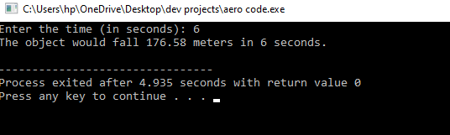

#include <iostream>

using namespace std;

// Function to calculate distance

double calculateDistance(double time) {

const double g = 9.81; // gravity constant

double distance = 0.5 * g * time * time; // distance formula

return distance;

} CODE: <06.cpp>

int main() {

double time;

cout << "Enter the time (in seconds): ";

cin >> time;

double distance = calculateDistance(time);

cout << "The object would fall " << distance << " meters in " << time << " seconds.\n";

return 0;

}

***In this program, the user inputs the time of free fall, and the program calculates the distance the object would fall in that time under the influence of gravity. The formula used is distance = 0.5 * g * time^2, where g is the acceleration due to gravity. This is a much simpler problem but still relevant to aerospace****.*